Get ready to experience the joy of rhythm, movement, and music in this high-energy session that brings learning to life! Using stability balls, drumsticks, and engaging music, Stomp, Drum, and Dance! invites participants to explore the powerful combination of music and movement while enhancing focus, managing stress, and promoting connection. Discover how Drums Alive® activates both the brain and body—all while inspiring fun, creativity, and meaningful rhythmic experiences you can bring back to your classroom.

About Drums Alive®
Drums Alive® is the original, research-based drumming fitness program that blends movement, rhythm, music, and cognitive applications to support physical, mental, and social-emotional wellness. Rooted in brain-based learning, the program’s DRUMTASTIC® curriculum engages students of all ages and abilities in active, inclusive, and energizing experiences. Join us to discover how to share the transformative power of Drums Alive®!

Sample Activities
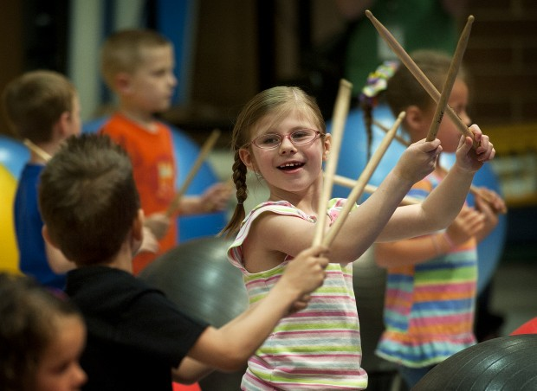
Splish Splash

Music: Splish Splash (performed by Bobby Darin)
Equipment: Drum Set (stability ball/bucket base), drumsticks
Formation: Partners sharing a Drum Set
Focus: Form, spatial awareness, collaboration

VERSE (64 counts)
- Tap partner’s drumsticks HIGH (hold 3 counts)
Click own drumsticks (1 count)
Double Beat on Drum (hold 3 counts)
Click own drumsticks (1 count)
Repeat all
- Same pattern, faster (1 count per move)—4 times total
- Repeat both slower and faster patterns
(Option: add jumping jack feet)

CHORUS (48 counts—Partner Drumming)
- 4 Double Beats on right side of Drum; 4 Double Beats on top of Drum
4 Double Beats on left side of Drum; 4 Double Beats on top of Drum
Repeat pattern—3 times total
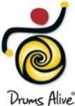
Hot Chocolate
Music: Hot Chocolate (from The Polar Express)
Equipment: Drumstick scarves (options: drumsticks, pool noodles, Boomwhackers, or hands!)
Formation: Windows
Focus: AB form, creative expression, rhythmic movement
On the Drums Alive YouTube page: Hot Chocolate Instructional/Performance Video

Structure of Music | Choreography
Intro: 48 counts | Creative movement
A: (“Hot, hot”)—64 counts total  4 counts  4 counts  8 counts  8 counts  8 counts  32 counts | Drumsticks out to the right in an “L”, then back in on “Hot, hot”  Drumsticks “rainbow” right to left  Repeat “L” on LEFT side and “rainbow” LEFT to RIGHT  Repeat “L” on RIGHT side and “rainbow” RIGHT to LEFT  Creative movement  Repeat ALL, starting on the LEFT side
B: (“Here we’ve only got…”)  24 counts  8 counts  24 counts | Charleston  “Jazz sticks”  Creative movement
A: 64 counts | REPEAT as before, starting on the RIGHT side
B: 40 counts  8 counts  8 counts | Charleston  “Jazz Sticks”  Creative movement
A: 64 counts | REPEAT as before, starting on the RIGHT side
B: 40 counts  8 counts  8 counts | Charleston  “Jazz Sticks”  Creative movement
A: 64 counts  56 counts | REPEAT as before, starting on the RIGHT side  REPEAT as before, starting on the RIGHT side
Coda: 24 counts  24 counts  20 counts  8 counts  9 counts  End | 3 frozen poses  “Jazz Sticks” from low to high  Go crazy! (Surprise—freeze for final 8 counts with the music)  Go crazy!  “Up and Out” with drumsticks  “Jazz Sticks”

PRIZE DRAWING!
Scan the QR code below for a chance to win either:
Drums Alive DRUMTASTIC & Ability Beats mp3 + mp4 download OR
DRUMTASTIC Mini Kit A
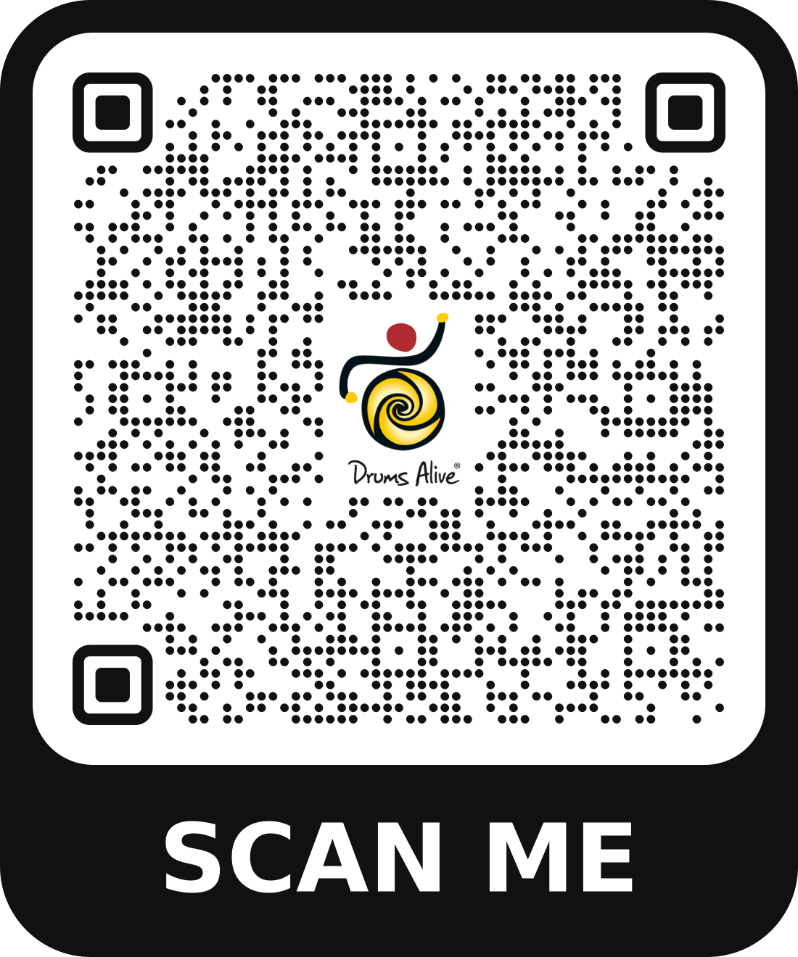

Want to know more about Drums Alive research-based programs and experiences?
Visit our website at www.drums-alive.com and/or contact:
Customer Support: (928) 421-3740 (M-F, 9am-5pm Eastern)
Email: help@drums-alive.com

FOR CASMEC 2026 CONFERENCE ATTENDEES ONLY

