Discover how Drums Alive® DRUMTASTIC can energize your classroom with the power of rhythm, movement, and playful creativity! This interactive session invites participants to experience engaging brain-and-body activities that boost physical, cognitive, and social-emotional health. Using music, stability balls, and drumsticks, you’ll explore cross-curricular lessons that spark imagination, support self-expression, and foster teamwork for learners of all ages and abilities. Participate in activities for K-8 and learn how to integrate DRUMTASTIC into your own teaching practice!

About Drums Alive®
Drums Alive® is the original, research-based drumming fitness program that blends movement, rhythm, music, and cognitive applications to support physical, mental, and social-emotional wellness. Rooted in brain-based learning, the program’s DRUMTASTIC® curriculum engages students of all ages and abilities in active, inclusive, and energizing experiences. Join us to discover how to share the transformative power of Drums Alive®!

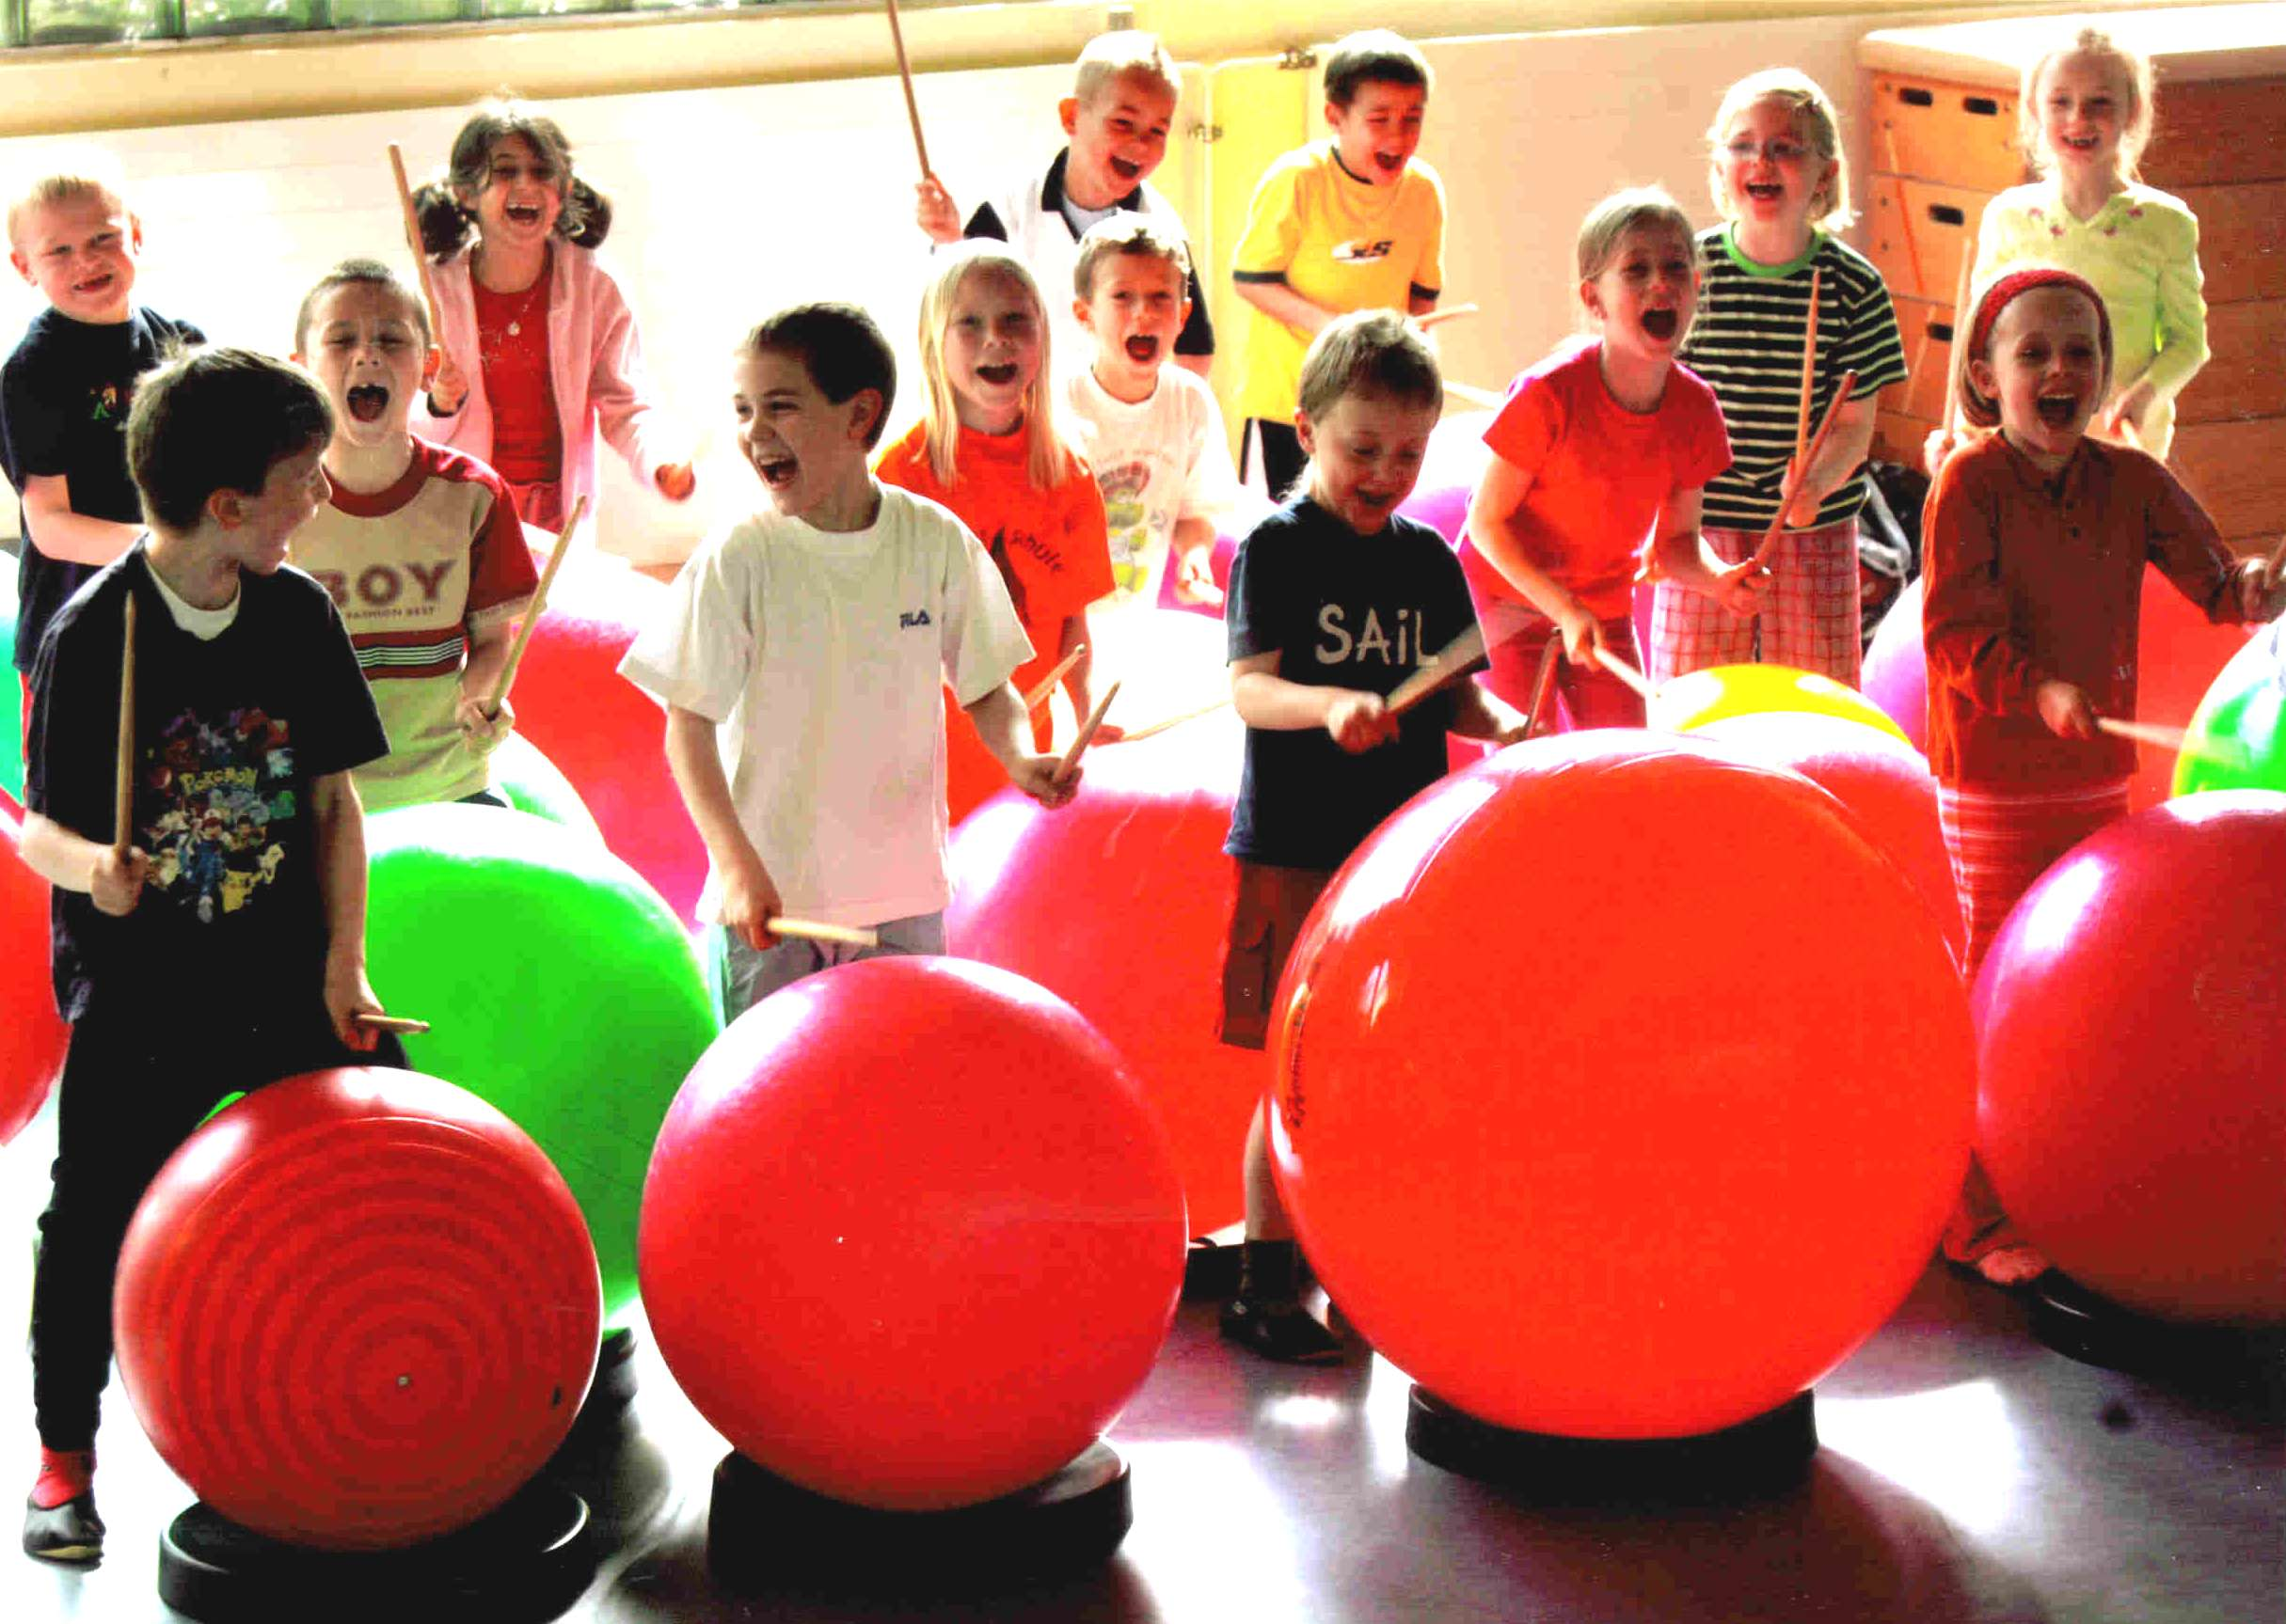

PRIZE DRAWING!
Scan the QR code below for a chance to win either:
Drums Alive DRUMTASTIC & Ability Beats mp3 + mp4 download OR
DRUMTASTIC Mini Kit A
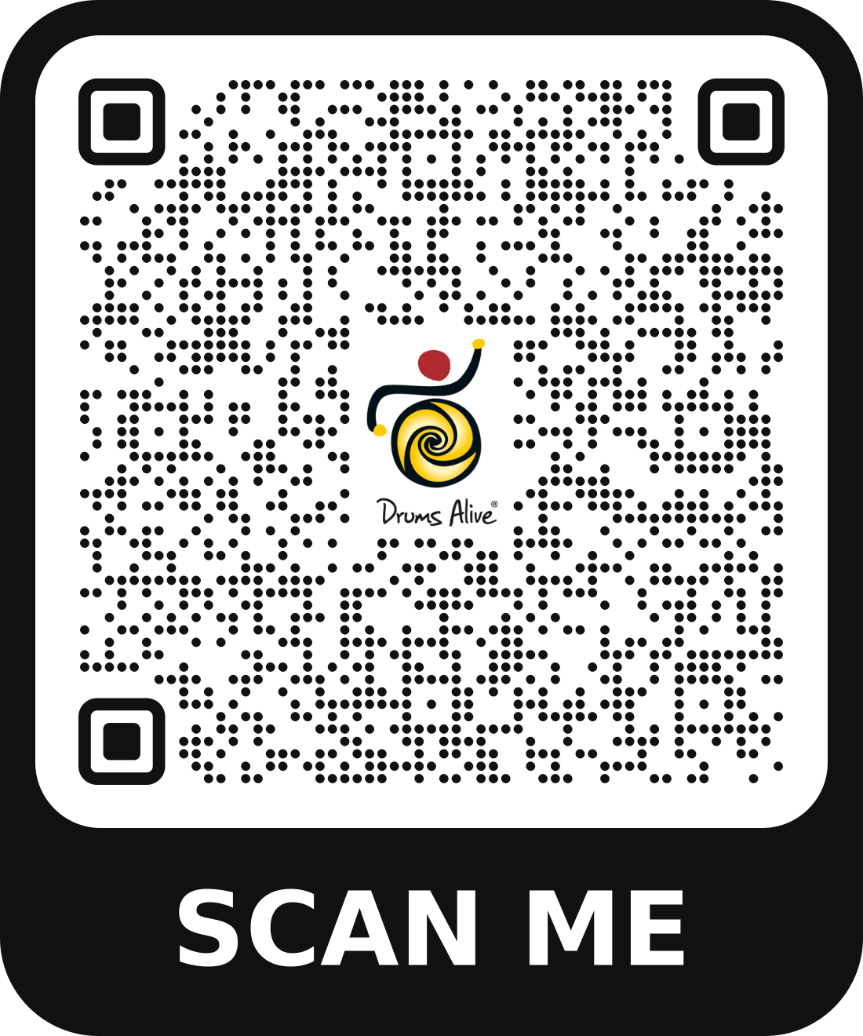
(Sample DRUMTASTIC Activities)
#1: Wipe Out

Music: Wipe Out (DRUMTASTIC & Ability Beats mp3+mp4)
Equipment: Drum Set (stability ball/bucket base), drumsticks
Formation: Windows or Scattered
Focus: AB form, chord changes (active listening)

Choreography Sequence:
A (melody): Travel around the room using a locomotor movement; tap Drums as you pass by
B (drumming): Rumble on right side of Drum (8 counts), then left side of Drum (changing with music)
**SURPRISE: Listen for the music to change after 4 counts, and change with it!

SEATED MODIFICATIONS:
A options: Select an upper body movement to perform (ex: Wave drumsticks in the air)
Tap drumsticks on floor (8 counts), then overhead (8 counts)—consider reducing to 4 counts
Tap 1 drumstick on floor and other in air (4 or 8 counts); switch
B: Rumble on right side of floor (8 counts), then left side of floor (8 counts)

#2: Let the Sunshine In

Music: Let the Sunshine In (DRUMTASTIC & Ability Beats mp3+mp4)
Equipment/Resources: Drum Set (stability ball/bucket base), drumsticks, Number Cards
Formation: Windows
Focus: Sequencing (frontal lobe), spatial awareness (parietal lobe), partner drumming (social connection)

Choreography Sequence:
8 Double Beats (8 counts)
8 Single Beats (8 counts)
4 Side Clicks (8 counts)
Travel to a new Drum Set (8 counts)
Repeat the sequence until the end of the song

TIPS:
- Allow time for students to experience each skill before progressing
- Consider increasing the number of repetitions for each skill if more practice time is needed
- Consider traveling around own Drum Set before traveling to a new Drum Set
- Use Number Cards to designate how many students share a Drum Set

Want to know more about Drums Alive research-based programs and experiences?
Visit our website at www.drums-alive.com and/or contact:
Customer Support: (928) 421-3740 (M-F, 9am-5pm Eastern)
Email: help@drums-alive.com

FOR CASMEC 2026 CONFERENCE ATTENDEES ONLY

