**Spice Up Your Strings: Rehearsal and Lesson Ideas for Tomorrow & Beyond**

Ruth Brittin, University of the Pacific

Darcy Ford, LIncoln Unified School District

Stockton, CA

California Orchestra Directors Association

CASMEC

Saturday, January 18, 2025, Sacramento, CA

**ADVANCE HANDOUT**

MORE COMPLETE VERSION WITH MUSIC EXAMPLES

will be available at the session

rbrittin@pacific.edu; dfordjames@lusd.net

"Sweet spot" on the Continuum of

Structure vs. Variety

Fixed & Predictable Variety is "Spice of Life"

Safety & Security Excitement & Engagement

Routines "Mixing it Up"

Foundation Spontaneity - The Spark

Creativity requires Both!!

**This session explores**

1) centering & exploring approaches

2) with different modalities

eyes, ears, bodies

3) music from an array of cultures... emphasis on being culturally expansive

4) technique - ex: right hand and left hand string technique development

**Developing Activities and Repertoire**

**Goal 1**: Use culturally-responsive approaches with different genres of music, with listening activities, improvisation, building pieces collaboratively

Process: Recordings and stimulating visuals and call/response format to develop comfort with

a) blues, jazz, pop-oriented genres (swing eighths, form)

b) taking turns, improvising

c) jamming culture

Example A: "Banana Boat" (YouTube Muppets with Harry Belafonte) for Call/Response

Example B: Darcy's visual for "Old MacDonald" (left-hand hand-shapes, Bornoff approach)

add to advance

Bornoff Hand Shapes (finger patterns):

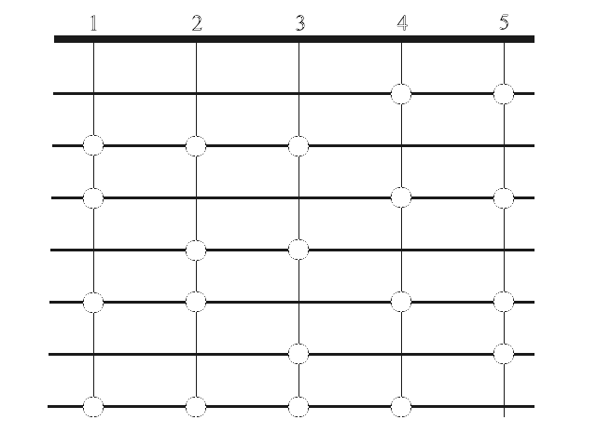

Half steps = "Best Friends" (for violins and most violas)

Different patterns make up different tetra-chords, put together = different scales/keys

Note - Bornoff materials will be available to peruse at session!

Example C: Example of Student Choice/Collaboration. Ukranian Bell Carol by ear and finger patterns.Class compositional process; comfort with the form = beyond notation.

Example D: "Bile 'dem Cabbage Down" and assorted fiddle tunes in method books (Mark O'Connor, Fiddler's Philharmonic, and through organizations such as "Kids on Bluegrass" (California Bluegrass Association) - more ideas available through Elizabeth Chappell's CASMEC session

**Goal 2**: Moving to Ensemble Literature: Repertoire that Builds Technique with Sonic Variety

Process: Compositional and pedagogical elements to writing/choosing repertoire, developing right and left hand, scaffolding certain components within a piece, embracing student choice

Examples: Grade .5 - Grade 2 Repertoire with swung eighth notes for blues/jazz, with pizz and bowings, and different minor keys for hand-shapes (Frost & Elledge, Susan Day, Deborah Baker Monday, Peter Martin, Ruth Brittin, Soon Hee Newbold, Alex Dudley, Mark Wood);

**Goal 3:** Engaging Students of All Ages: Critical Thinking to Spark Creativity

Process: Questioning Strategy approaches that appeal to different developmental levels, types of ensembles

Examples: videos and descriptions of questioning specificity, timing, student/teacher interactions, structure and variety over time; examples of Grade 2-4 pieces excellent for building critical thinking skills including Yukiko Nishimura, Adrian Gordon

Quote to Live By: *Students have the educational right to learn more about music than the 3rd clarinet part [or the second violin part].*

Lawrence McQuerry, University of the Pacific legendary professor of music education

**Goal 4**: Gamification for Critical Thinking

Process: Games that illustrate Critical Thinking processes and how to make them time-efficient with visual, aural, and kinesthetic approaches, plus the role of nostalgia (even for teenagers!)

Examples: 20 Questions, I Spy, Guess that Tune, Funny Position, 3 Times in a Row, Darcy's "The Wheel of Names" as focus/motivation (and beyond), string technique-specific games (bow races, windshield wipers (anything in a rhythm becomes fun, and can be turned into a game)

While games might seem "young", we all know we need brain breaks. A game might be the perfect brain break for your high schoolers!