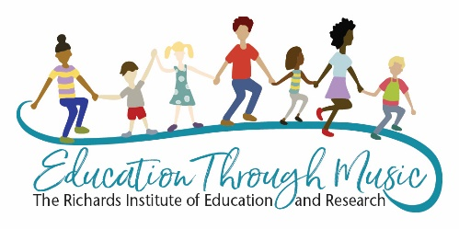 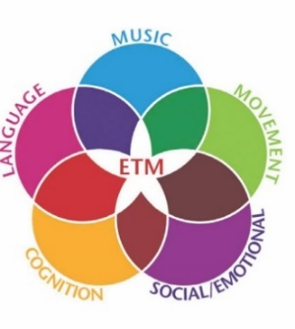

Topic: *Building Music Literacy Through Play: The Song Games of Education Through Music*

I. Education Through Music seeks to reach the child in five domains:

Music, Movement, Language, Social Emotional and Cognitive (Imagination)

II. Play is the most natural vehicle of childhood.

The erosion of play has been shown to be related to the following problems:

* Rise in attentional and interactional difficulties
* Poor resiliency
* Increased problems with self-regulation
* Degradation of adult-child interaction including
* Reduced interest in the world around them

-not as explorative as we want, creating low or poor motivation, which leads to reduction in the ability to create meaning (functional literacy)

III. Brain Connection: Emotion precedes cognition

We know an emotionally-secure child learns better. How do we lay that foundation?

We use songs that:

* + Develop an adult/child bond (relationship), provide joy, a sense of regard and well-being.
  + Put play at the center of learning. Play reduces anxiety and opens child for learning. (Elkind, Perry)

IV. Develop Auditory System in the Lead-Moves a Child Toward Literacy

Use language-based music - not just any songs, but music which has high-level “book language” (Wolf). Intentionally-chosen songs load language into the child. Language builds the imagination in early childhood and develops vocabulary in older children. We want a linguistically-able/musically-able child with songs which follow the prosody (flow of language) and build context out of the visual support from movement and use of solfege to represent specific sounds and their relationship to one another.

Nina Kraus, Maryanne Wolf, John Medina and Bruce Perry are just a few of the references from today’s presentation.

For a full bibliography and information of the repertoire and where to sign up for courses in Education Through Music go to [www.new.richardsinstitute.org](http://www.new.richardsinstitute.org) or contact [marie@richardsinstitute.org](mailto:marie@richardsinstitute.org).