The Adaptive Music Educator: Ensuring Access to a High Quality Music Education in the General Music Classroom

Dr. Erin Zaffini
Longy School of Music

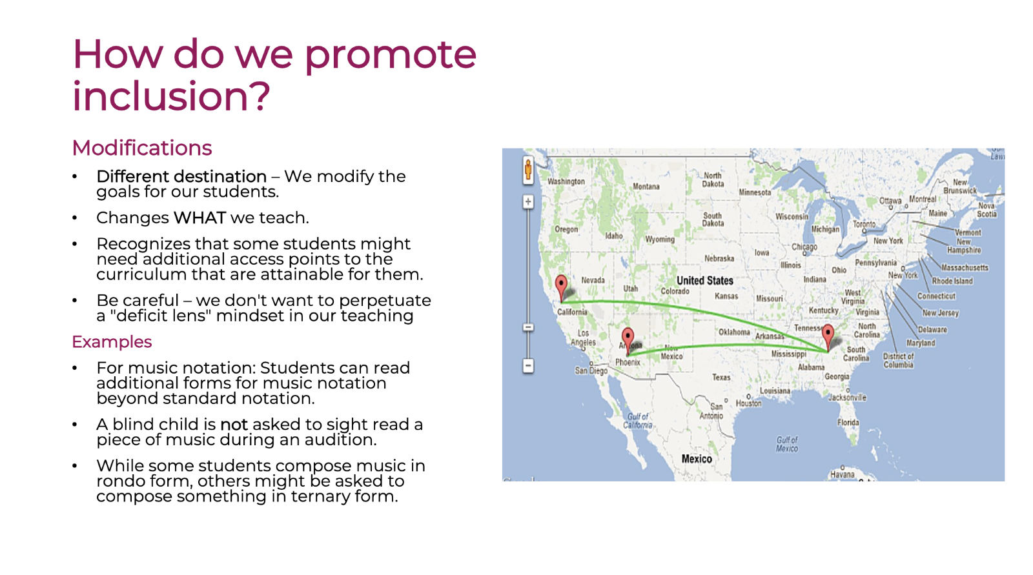
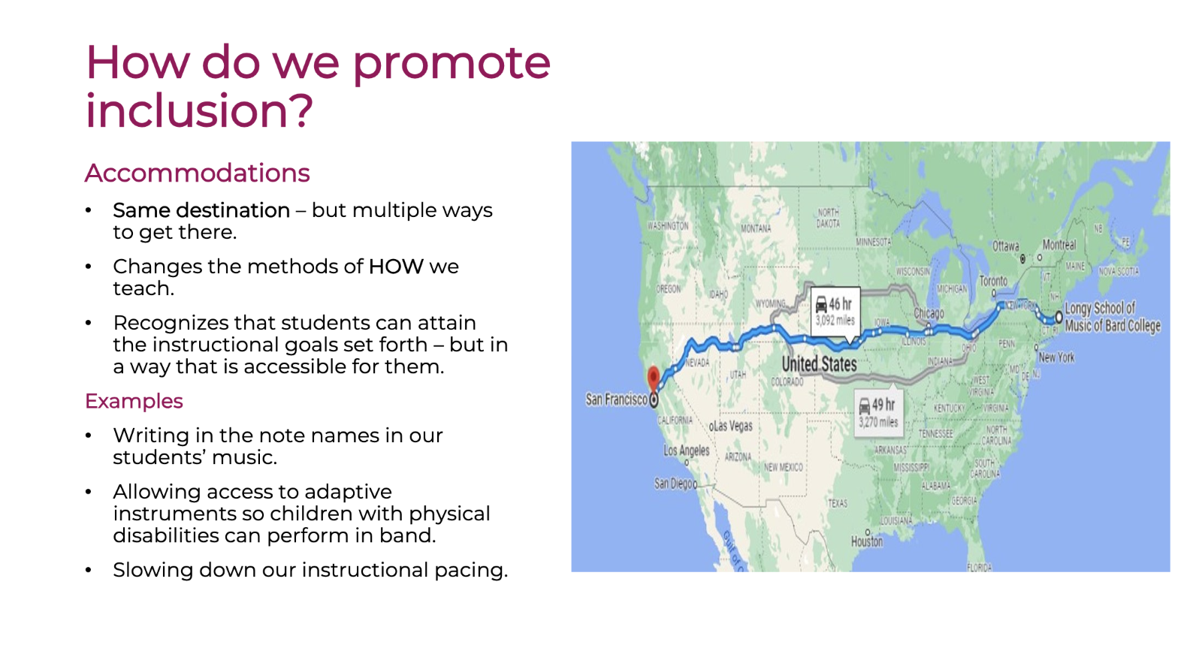
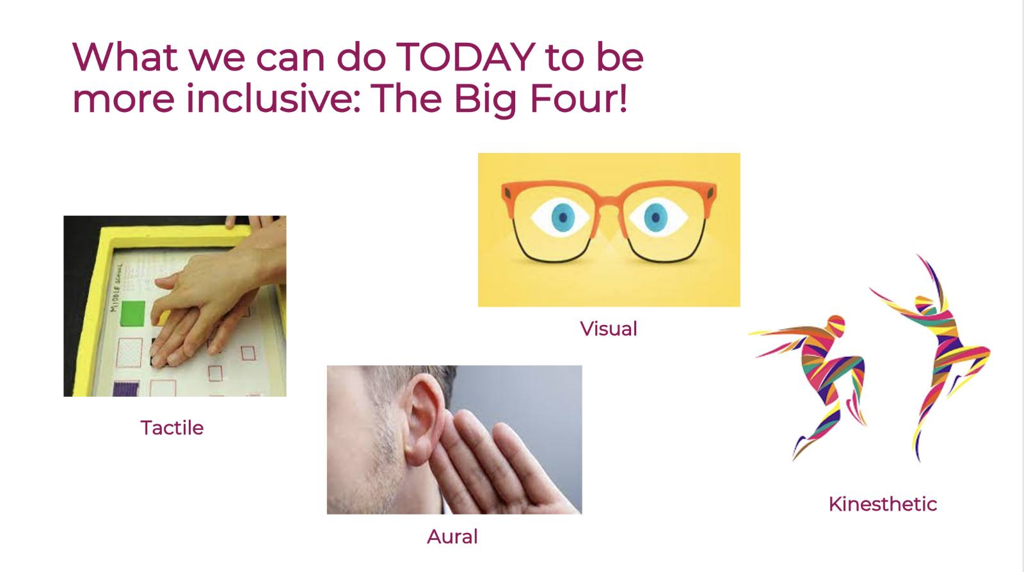
Use as many of the above four approaches to teach the same content as possible!

Consider giving multiple opportunities for students to show you their learning - not everyone will show their present level of skill or understanding in the same way.

